There are two SVG images in this file, both exported from Inkscape:
- a straight Bezier curve with a circular arrow tail and a triangle arrowhead
- composition of three shapes: a circle, a rounded rectangle and a triangle

The two objects look almost the same in Inkscape. A very minor difference is in the shape of the triangle arrowhead:
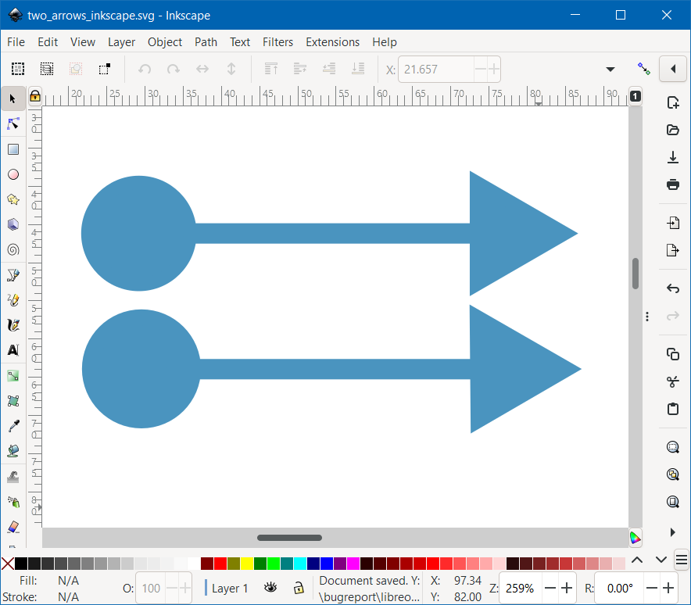

In LibreOffice 7.4.0.3 Writer, they look very different:
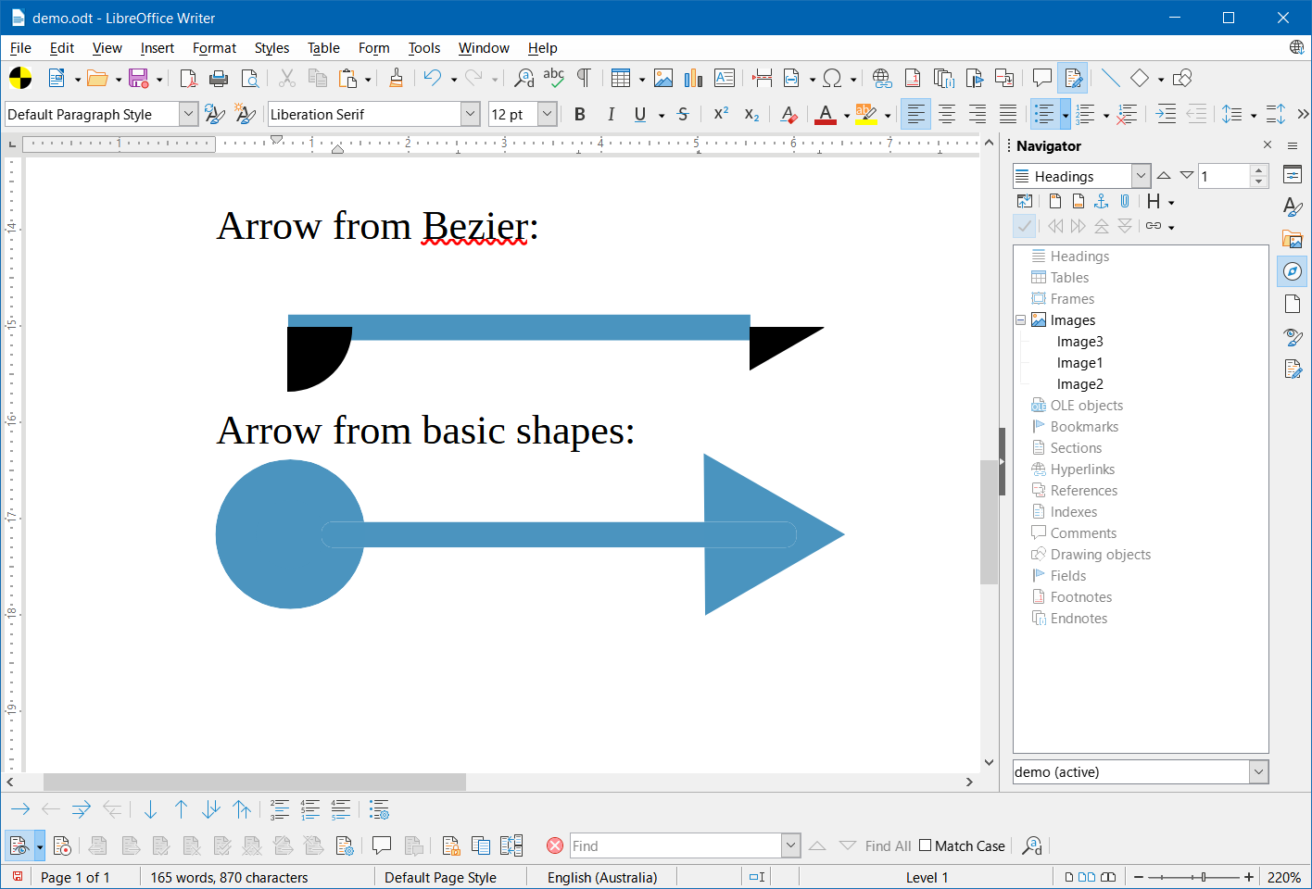
Arrow from Bezier:

Arrow from basic shapes:


Bugs in Writer:
- the tail of the Bezier arrow is a black quarter of a circle instead of a blue complete one
- the head of the Bezier arrow is just half of a black triangle instead of a complete blue one
- the contours of the rounded rectangle at both ends are visible light blue lines, which should be flat blue, having the same color as the circle and the triangle

